Prototype DRP Finder

By: Maurits Krijnen
Version: 1.1
Date: 24/03/22
Version | Description
1.0 | Initial release
1.1 | Implement feedback from interview; removed unnecessary functions.

Table of Contents
Description 3
Model prototype: 3
Explanation 4
Import images 4
Remove selected 4
Export images 4
Image List 4
Image Display 4
Approach 5
Conclusion 5

Description
Prototypes are project management tools that are used in getting early feedback that is related to the project requirements. This is done by providing a working model of the product even before building it. They are tangible models thus, the stakeholders can experiment with it and have a clear idea what the product will be like.
One of the benefits of this tool is that it allows the stakeholders to discuss their requirements for the product instead of discussing abstract representations of the project. It also supports the concept of progressive elaboration using the mock product. It is also a great way to generate feedback so that the appropriate revisions can be carried out on the final product.

Model prototype:

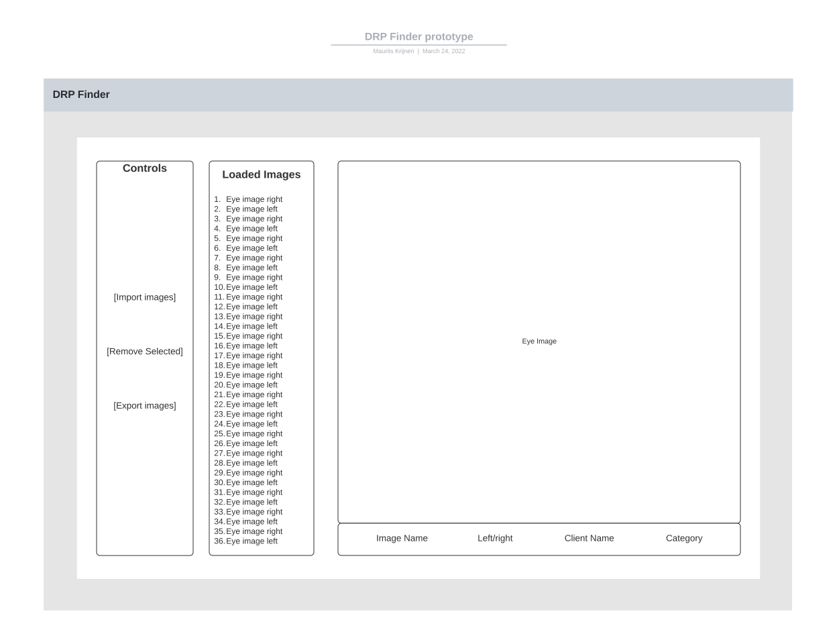

Explanation
The model shows the main screen the user will see when starting up the application
The box to the far left displays a list of buttons the user can press:
- Import images
- Remove selected
- Export images

Import images
The user can select 1 or more files for the application to load in. Any images accepted by the application will be loaded and displayed in the Image List to the right of the buttons.

Remove selected
Remove selected images from the Image List.

Export images
Export selected images with a short description
In addition to these buttons the following can be viewed

Image List
To the right of the buttons is a list displaying the names of all loaded images. The user can interact with the items in the list.

Image Display
The large area to the right displays the currently selected image. Below the image some additional information is displayed. The user will be able to edit the information by for example changing the image name.

Approach
My approach for this document was to first imagine what the application would look like in it s final state. From here I started adding some of the important parts like the image box and the buttons that are used to interact with the application.
After adding the essentials I started thinking about functionality. What would I want to do if I was a user? This line of thinking helped with creating the list of requirements for the requirements document.
In order to confirm if my thought process was correct I demonstrated the model to the stakeholder. Here I explained how I envisioned the application and asked them if they agreed with my reasoning, or if there was context that I was missing.

Conclusion
During the creation process I was unsure of what the scope of functionalities would look like. But creating the model helped me gain a better understanding of what kinds of functions would be expected and/or required by a user.
The model was also very useful for discussing the functional requirements of the project. Discussing the model also gave me a new perspective on what functionality is required on the dashboard, and how a user would most likely interact with it.

